**Low Fidelity Prototype**

Recipe List Web Application

COMP4952

9/22/2013

Contents

Description of the interface 3

Interface 3

Application Requirements 3

User Centered Design Techniques Used 4

Risks & Issues 5

Page Wire Frames 6

Logged out home (desktop) 7

Logged out home (mobile) 7

Logged in home (mobile) 8

Search 8

Search results page 9

View Recipe 9

Add Recipe 10

My Lists 10

List Admin 11

View List 11

Create New List 12

Invite to List 12

# Description of the interface

Given the use of User-Centered Design throughout the life-cycle of this project, we are currently unable to provide precise specifications of either the interface of the application requirements. That said in the following section will provide a brief description of both the UI and the application requirements based on those that are deemed necessary and desirable by the designers of the application. Once these have been articulated and run through the first round of usability testing they will be reviewed and revised as necessary.

## High Level Goals

This application looks to compete in the competitive app market place by providing users with an easy to use application that makes organizing weekly shopping easy for individuals and families. We will accomplish this goal by developing an application that makes looking up and discovering new and exciting recipes simple and fast. We believe that using recipes to build shopping lists will be unique and novel enough to draw users to our application and that once they begin using it they will continue to do so based on the ease with which grocery shopping can be shared with their eating companions.

## Interface

The application will be divided into two major sections: public and private. The public section of the site will include a sign-in section, sign-up section, as well as pages explaining the use of the application (about pages). The private section will include profile management pages, invite pages, create list pages, search recipe pages, add recipe to list page, and list management/view pages.

The interface will need to be responsive to the pixel width and height of the screen. This will mean that the site will respond to mobile and desktop size sites. The general layout will utilize a tile based UI as much as possible for both page layout and navigation.

## Application Requirements

The following section outlines our application requirements as a list of imperative statements about the functionality of the end product (the application). Each separate statement indicates something that the application must be able to do in order for it to be considered complete.

* The User must be able to sign up an account using an existing email address
* The User must be able to start a new shopping list
* The User must be able to invite other signed up members to an existing shopping list
* The User must be able to solicit an invitation to an email address not associated with a member account (this requirement may need to be removed based on implementation complexity)
* The User must be able to search for recipes
* The User must be able to add recipes to their shopping list
* The User must be able to exclude items from being added to their shopping list from a selected recipe
* The User must be able to view their available shopping lists
* The User must be able to view the details of a shopping list they are on
* The User must be able to assign shopping list items to themselves or other members on the list
* The User must be able to mark a recipe item on the list as purchased
* The User must be able to remove a recipe from the list
* The User must be able to edit the details of a recipe currently on their list
  + Add items back onto the list
* The User must be able to edit their profile
  + Email, password, screen name and list item color
* The User who created a shopping list should be able to delete the list
* The User who created a shopping list should be able to remove members from the list

# User Centered Design Techniques & Heuristics Used

* UI Consistency
  + The system will use a UI that aims to be as consistent and general as possible. This will be achieved using simple tile based navigation as well as simple and repeatable task flows.
  + We will ensure we conform to consistent language use across multiple tasks so that different tasks can be related by the user to know where they are in an unfamiliar situation.
* Modal Dialog Feedback
  + The system will regularly inform users when a task has been completed so that they can know for sure that they have been successful
  + This feedback must be as nonintrusive as possible
  + Modal dialogues will be used for closure
* Session based task completion
  + Most tasks associated with the addition of lists, modification of lists, or destruction of lists might need to be multi-step procedures that alert their users to their progress and completion. If this is the case, the information the user enters should be tracked in the session so that the user can abandon any of these actions without a confusing navigation experience and take them up or restart them later on. This will accommodate the easy reversal of action and prevent the user from having to re-enter form information should they accidentally navigate away without committing their action.
* Language based on recipe API
  + The recipe database that we are using draws information from a number of popular recipe websites. We are able to leverage this in order to make sure that the information presented to the user is in the language they are used to.
* Error prevention
  + The user should not be exposed to any internal, system or connection based errors.
* Minimalist design
  + The tile design will ensure that both the desktop and mobile versions of the site will be familiar and simple to navigate
* Recognition rather than recall
  + Ensure that the website’s navigation and UI are repeated over numerous tasks and always consistent so that the user doesn’t need to consistently attempt to remember how to complete a task
  + Ensure that all multistep tasks carry data over from step to step to prevent the user from
    - Having to remember what they were doing
    - Re-enter information in the case of having to go back a step during an activity
* Flexibility and efficiency of use
  + Mobile site will make the application easy to use from anywhere they can access the internet
  + Favourites functionality related to saving recipes will make using the application quicker for more experienced users

# Risks & Issues

|  |  |  |  |
| --- | --- | --- | --- |
| **Risk / Issue** | **Explanation** | **Tasks** | **Outcome** |
| We don’t have a web server to host the web app | We don’t have a permanent host for our web app. Not critical, as we don’t have plans to deploy or use this web app outside of school. Instead, we can host the web app locally, and also use it while debugging in visual studio. | N/A | N/A |
| Our web app is meant to be used from the desktop and from mobile devices, but we don’t have the resources to perform QA on a large number of devices & web browsers | Because of the time-limited nature of the project, we must restrict the number of targeted devices and web browsers to a manageable quantity. | Decide which mobile devices and desktop web browsers to perform testing on. | We will restrict targeted devices to those that we own ourselves:  iPhone 4S running iOS 6.0 (built-in browser)  Nexus S running Android 4.1.1 (built-in browser)  We will restrict desktop web browsers to:  Chrome (latest)  Firefox (latest)  (All running on Windows 7 64-bit SP1) |
| Yummly (our chosen recipe API service) may alter or remove their APIs, or remove free access to their APIs | Our chosen recipe API may become undesirable or unavailable if they discontinue their API, modify their APIs, or otherwise remove free access to their APIs | Need to research possible free alternative recipe APIs | Several are available with similar free account terms:  http://food2fork.com/  http://api.bigoven.com/‎  http://www.recipepuppy.com/about/api/ |
| We may hit Yummly’s API usage limits while developing and testing our app. | The free version of the Yummly recipe API has a limit of 500 API calls per day. | We should create additional Yummly accounts if we need to temporarily get around this limit. | N/A |
| Yummly recipe ingredient names and units of measurement can vary from recipe to recipe. This will cause problems when adding ingredients to shopping list (i.e. duplicate items, and errors in quantity calculations) | Yummly uses multiple source recipe websites, and there is no guarantee of consistency between sources. Source websites may differ by:   * units of measurement (“oz” versus “cup”) * Formatting (“1 teaspoon” versus “1 tsp”) * Ingredient name (“minced garlic” versus “garlic” versus “garlic, minced”)   However, individual sources appear to be internally consistent. | We should limit our search results to a small number of approved sources that are consistent and easy to parse. Yummly provides the recipe source in its search results, which will allow us to filter out non-approved sources. | The following sources have been chosen (this list may change as development progresses):   * Food Network * AllRecipes * Simply Recipes |

# Page Wire Frames

The following wireframes show the pages of the site in a minimalist format primarily for conceptual purposes. Only one example is given of the desktop version of the site since the mobile layout is more important and the desktop version of the site can be extrapolated from the mobile version after the first example.

## Logged out home (desktop)

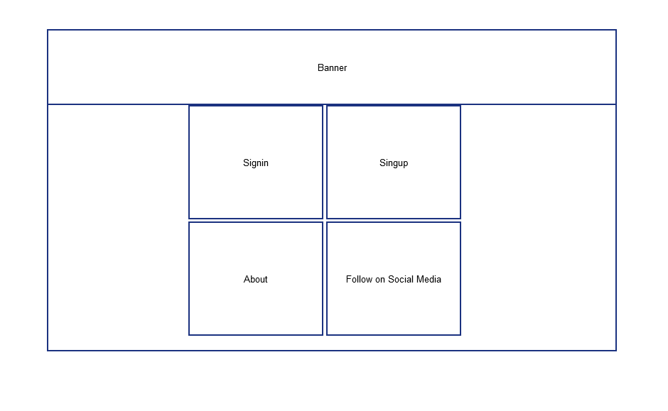

## Logged out home (mobile)

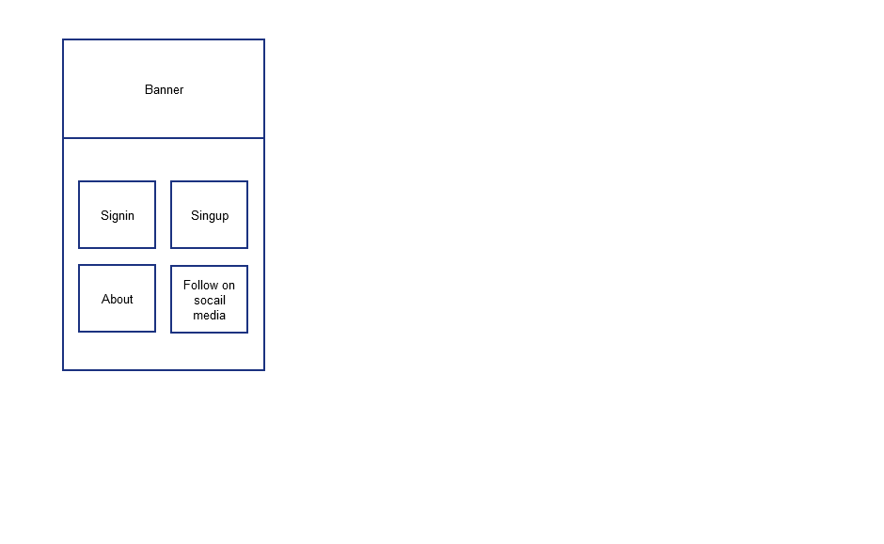

## Logged in home (mobile)

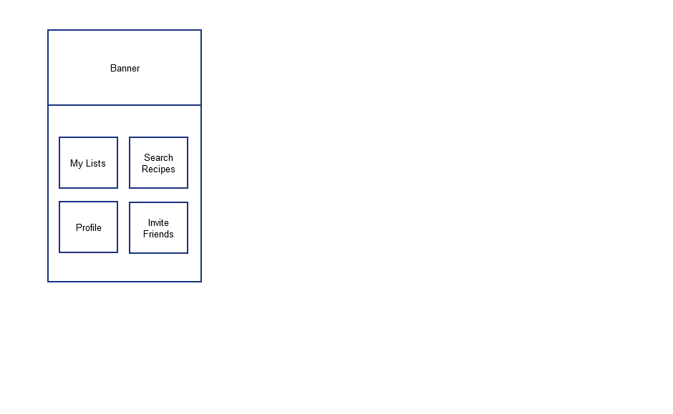

## Search

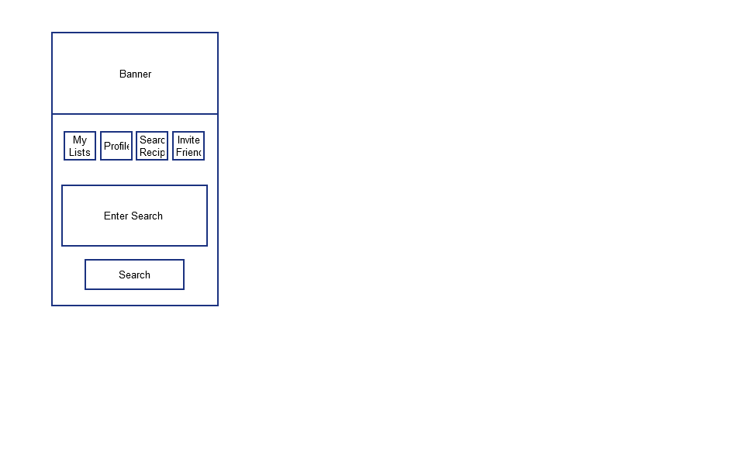

## Search results page

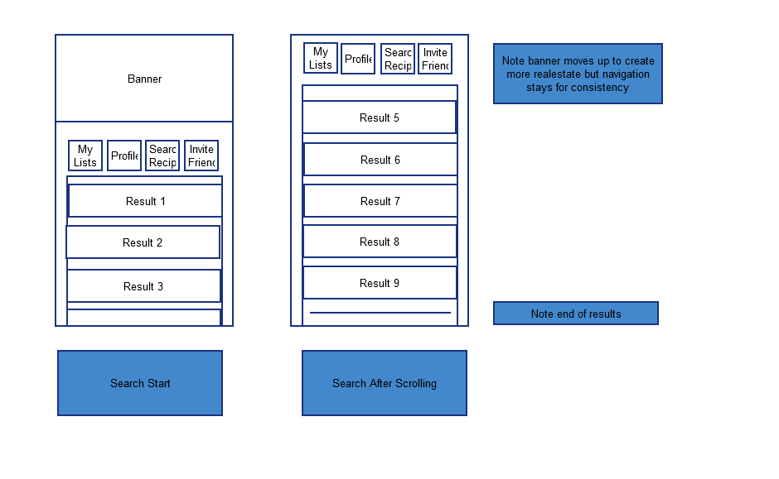

## View Recipe

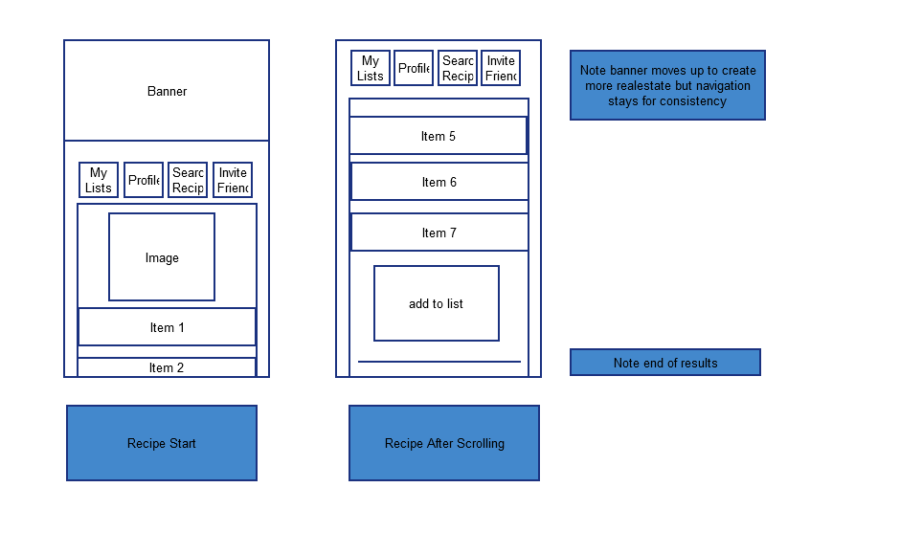

## Add Recipe

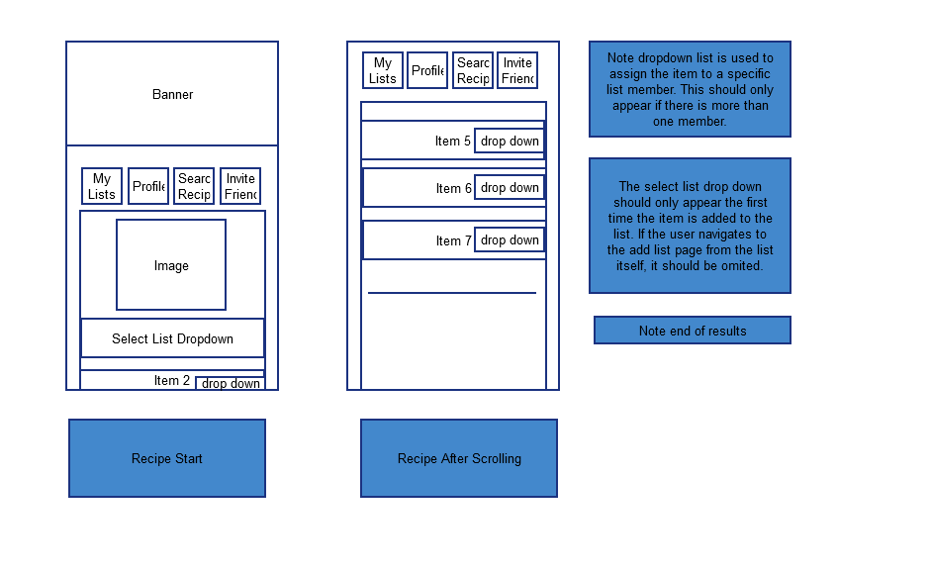

## My Lists

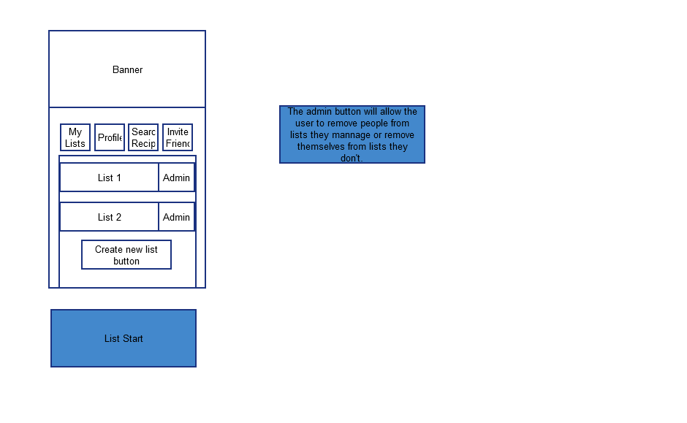

## List Admin

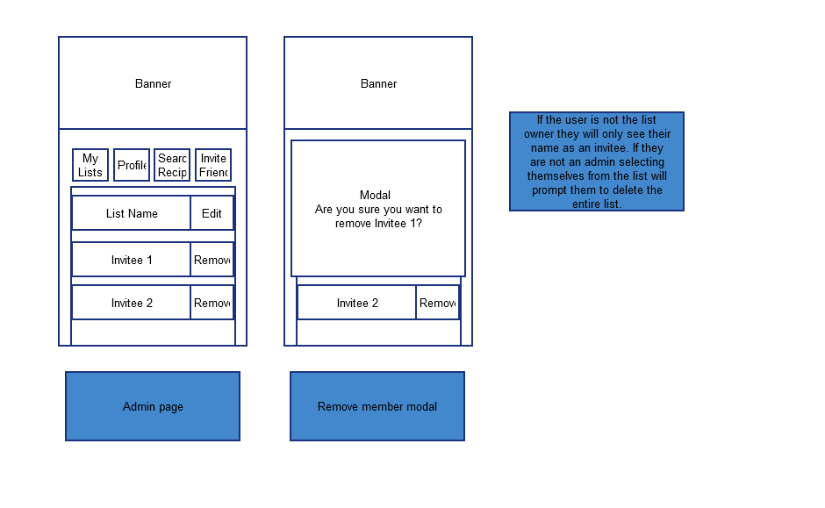

## View List

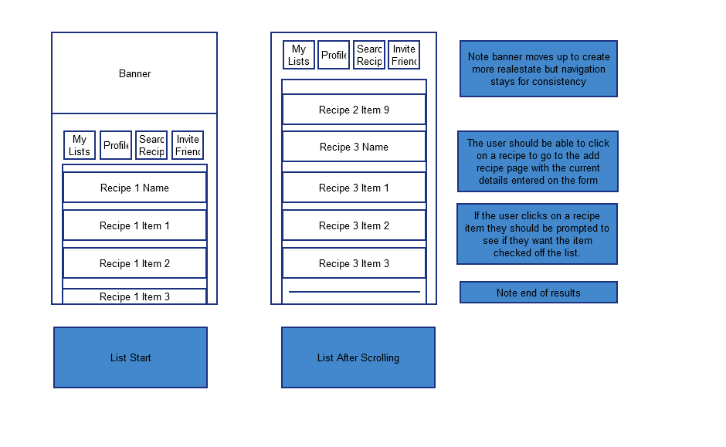

## Create New List

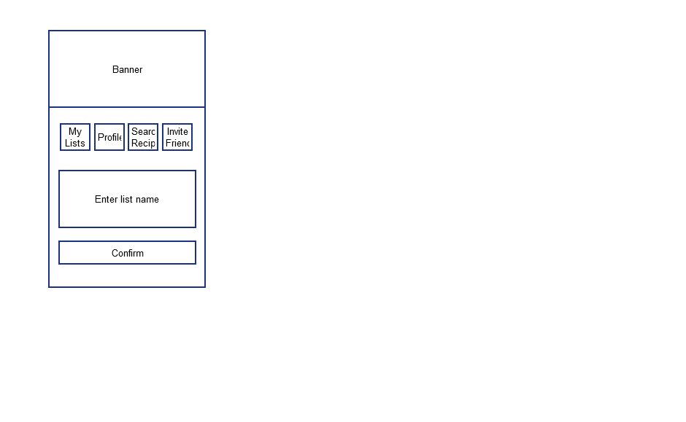

## Invite to List

